North Carolina Fire Marshal’s Association Committee Reports
( ) Scholarship (X) Education ( ) Legislative
( ) Technology ( ) Code revision ( ) Fire Investigations
( ) Nominating ( ) Audit ( ) By-Law

NCFMA 4th Quarter Education Committee Meeting 10/20/2025 0900

Meeting Minutes:
The meeting was called to order on October 20, 2025 at 0900.
Charlie Johnson gave the following updates from OSFM. The general assembly is back in session today (Oct. 20, 2025) hearing rumbles, they may be on working appointments to the Building Code and Residential Code Councils. OSFM engineering staff is attending the ICC annual conference in Cleveland, Ohio this week. Charlie spoke briefly about the code updates classes and the possibility of adding more classes throughout the year. Discussed about also hosting a Wake County area class, more to come on additional classes.

Jeff Johnson gave an update on the Fire Marshal 101 course, to date we have had 442 attend 15 classes. We have upcoming classes at Cleveland Community College starting on November 13 (Seats are still available) and following that, Kernersville FD starting on November 17th, (that class is full).
Jeff also spoke about the 2026 schedule of FM-101 classes listed below is the most current update:
  - 2026 FM 101 Classes:
    - January 26-29, 2026, Rocky Mount
    - February 19-22, 2026, Murphy
    - April 20-23, 2026, Pinehurst
    - May 18-21, 2026, Smithfield
    - July 20-23, 2026, Winterville
    - August TBD – State ETC
    - September TBD – Laurinburg/Rockingham
    - October TBD – N. Wilkesboro
    - November 2-5, 2026 – Brunswick Community College, Bolivia
Luke McKenzie asked about Fire Marshal 101 class at the Mid-Winter Chief’s Conference, May 12-16, 2026. At this time nothing has been planned, will reach out and possibly have a class again next year.

Reminder the Summer/Fall Classes – Underwriters Laboratories Energy Storage, Todd Iaeger, November 12, 2025, Washington, NC. Thomas Raper advised there are currently 22 pre-registered for this class.

Charlie Johnson discussed the schedule of 2024 Fire Code Update Classes starting on December 5 and into 2026.
  - December 5, 2025 - Hickory/Conover Currently 49 pre-registered.
  - January 8, 2026 - Morehead City Currently 4 pre-registered. (Moved to the Morehead Convention Center)
  - February 12, 2026 – Pittsboro/Chatham County Currently 14 pre-registered.
  - April 16, 2026 – Kernersville Currently 8 pre-registered.
Group discussion on possibly hosting a Charlotte Fire class around May-July 2026 time frame, more to come on that.

Tim Henshaw gave a report on the 2025 Fire Marshal Institute. The committee is regrouping now and preparing for the 2026 institute. Encouraged everyone to complete the NCFMA survey https://forms.gle/cRWoY2WWdyybGANGA. Planning for a meeting in November of the institute committee to discuss topics and instructors for the 2026 Fire Marshal Institute. Looking for additional instructors and topics if interested please reach out to someone on the committee.
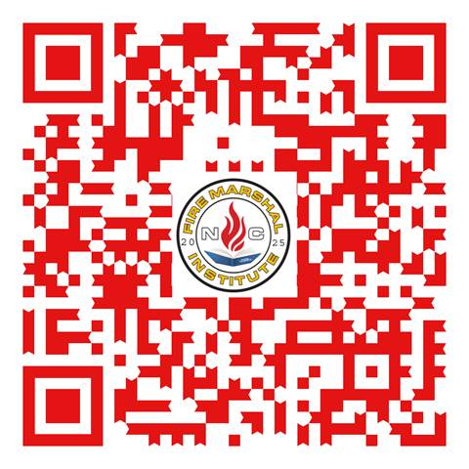
Reminder the ICC Class for Fall 2025, Chatham County EOC, 112 Innovation Dr., Pittsboro, NC. November 13, 2025, 2021 IFC-Fire Protection and Alarm Systems

Any additional business or educational opportunities.
Charlie Johnson reminded everyone about the upcoming NC Fire Safety Summit on Tuesday, November 18, 2025 at the Hickory Convention Center, Lunch will be provided. Also, a code updates class he will be presenting in Winston-Salem for AIA on November 19th, 2025.
Charlie Johnson also reminded everyone about plans for the Fire Prevention School on March 16-20, 2026. He will be attending a meeting this week for further planning, new instructors, and classes this year.
David Stone discussed a November 10th UL Town Hall training/meeting in Wilmington Todd Iaeger will be presenting. This may be a virtual option, more to come on that.

No further business the meeting was adjourned at 0933 hrs. on 10/20/2025.

Present were:
Tony Smart
Charlie Johnson
Jeff Johnson
Bobby Carmon
Bob McSorley
Charles Eldridge
David Stone
Chris Jenkins
Luke McKenzie
William Judson
Tim Henshaw
Thomas Raper
Buddy Thompson

